**Week 2_PL/SQL _HandsOn**

**Exercise 1: Control Structures**

**Scenario 1:**

CREATE PROCEDURE ApplySeniorDiscount()

BEGIN

UPDATE loans

JOIN customers ON loans.customer_id = customers.customer_id

SET loans.interest_rate = loans.interest_rate - 1

WHERE customers.age > 60;

END $$

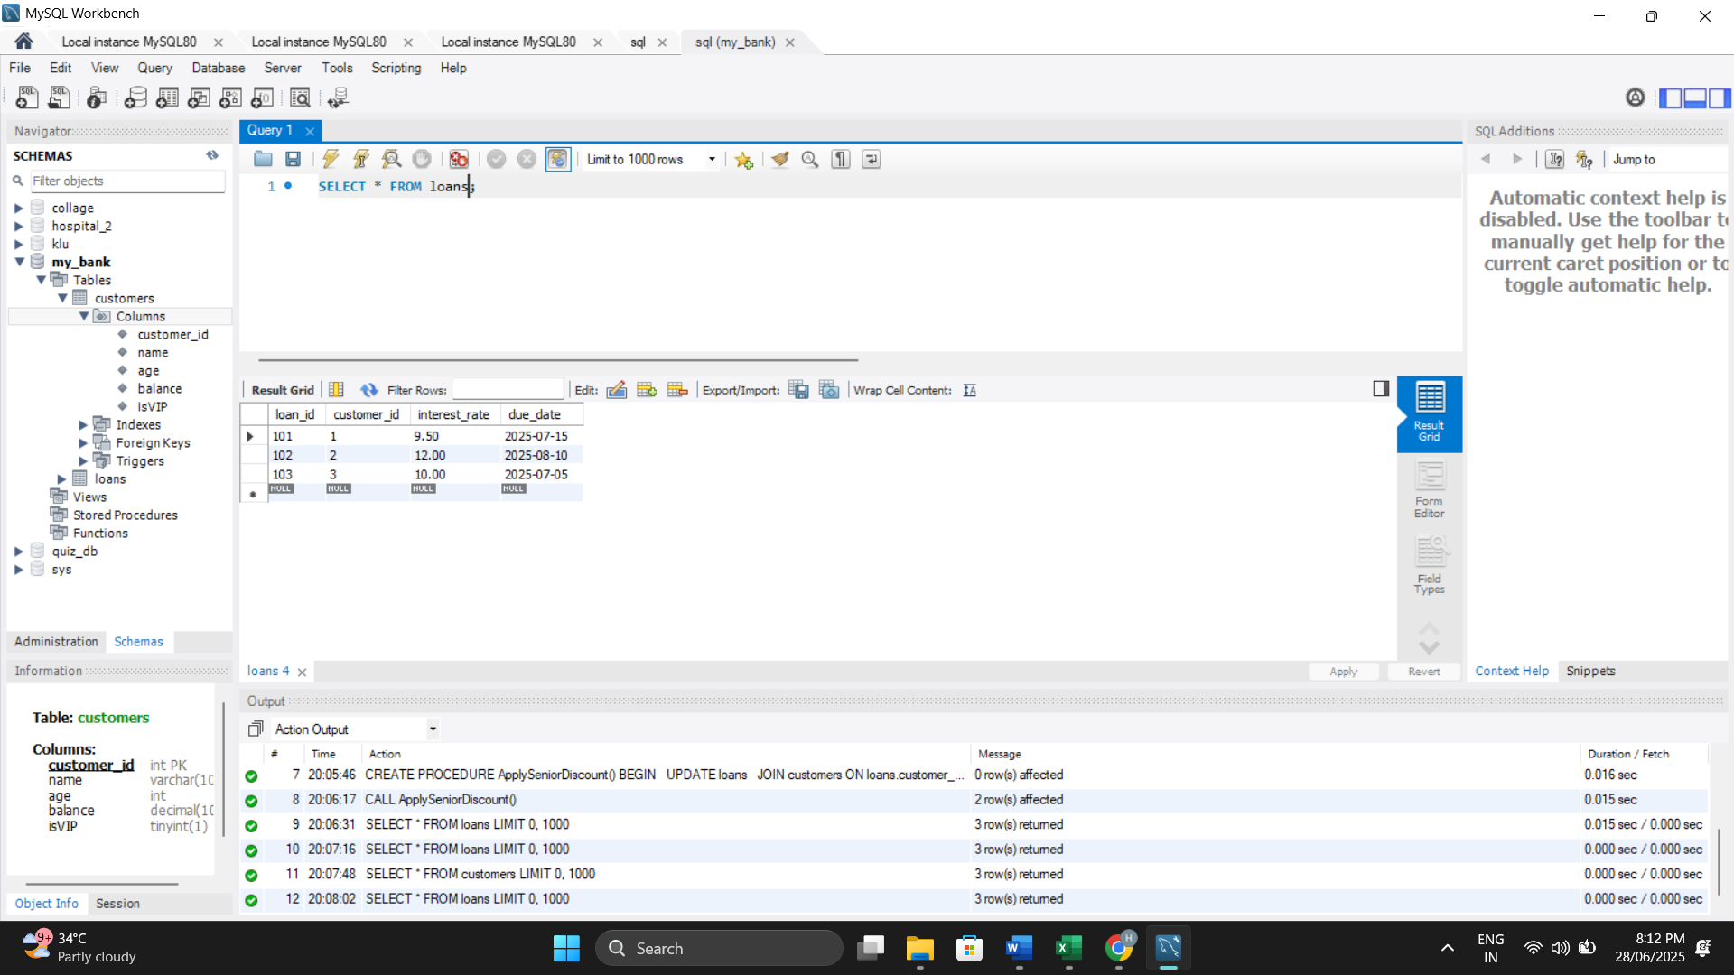

**Scenario 2:**

CREATE PROCEDURE PromoteToVIP()

BEGIN

UPDATE customers

SET isVIP = TRUE

WHERE balance > 10000;

END $$

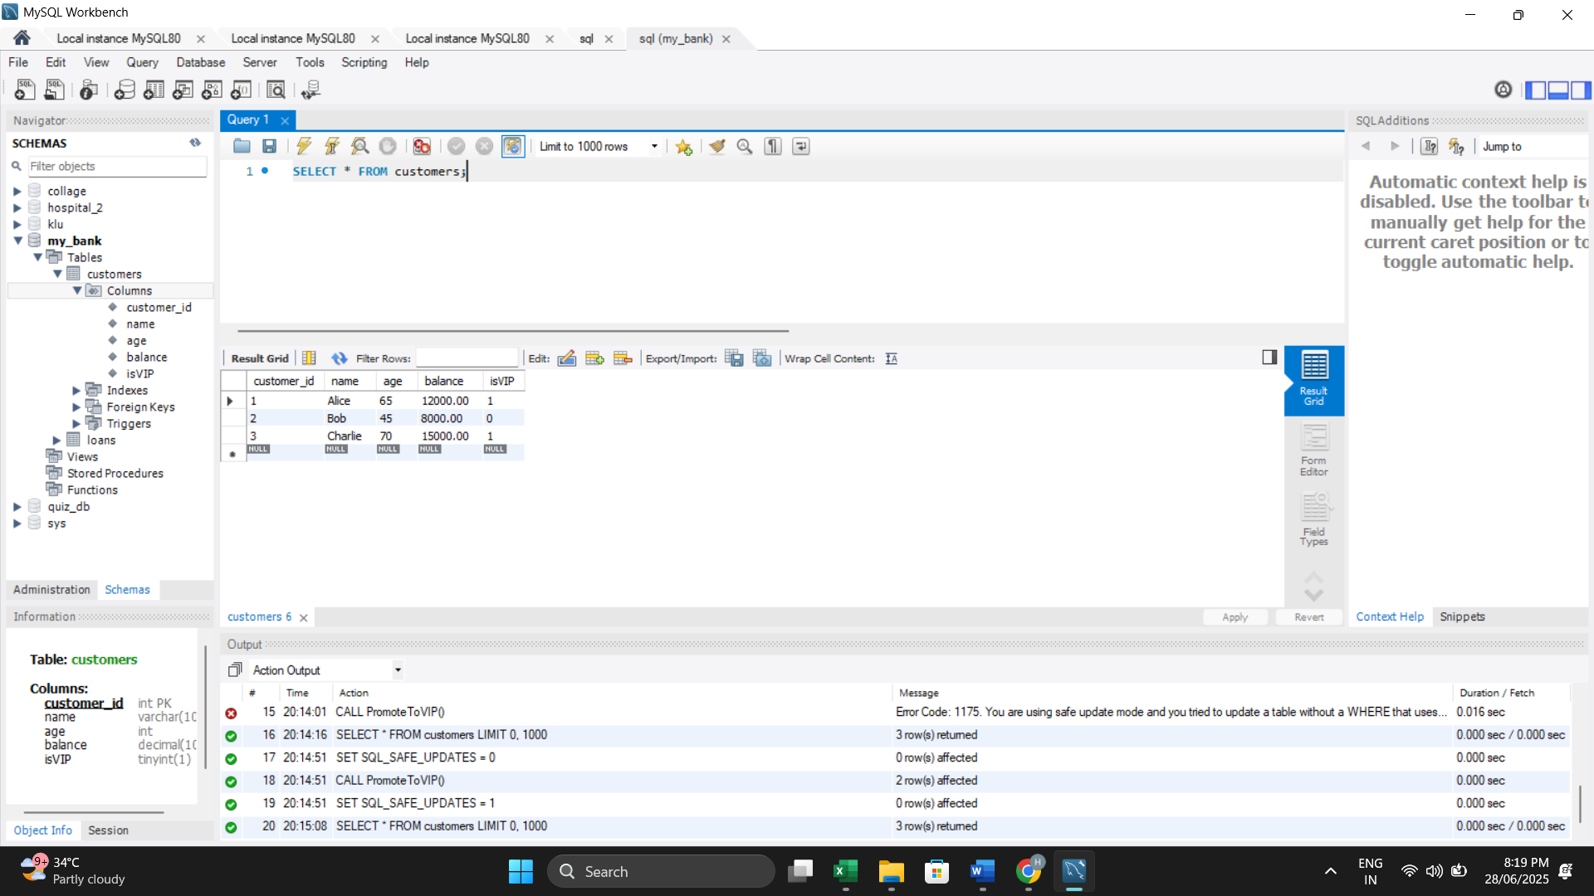

**Scenario 3:**

SELECT

CONCAT('Reminder: ', c.name, ', your loan is due on ', DATE_FORMAT(l.due_date, '%d-%b-%Y')) AS Reminder

FROM

loans l

JOIN

customers c ON l.customer_id = c.customer_id

WHERE

l.due_date BETWEEN CURDATE() AND CURDATE() + INTERVAL 30 DAY;

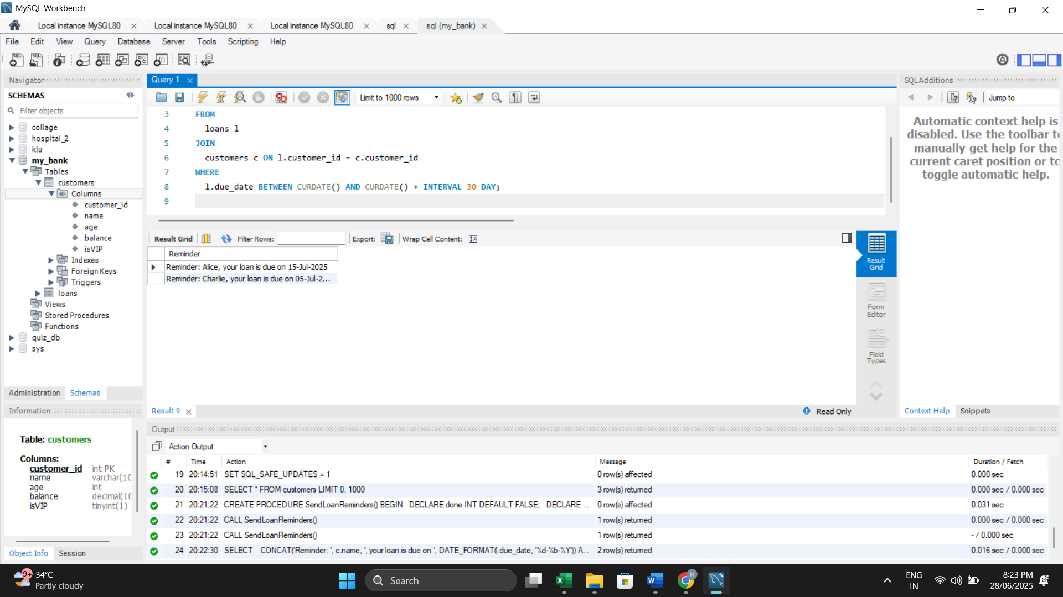

**Exercise 3: Stored Procedures**

**Scenario 1:**

CREATE PROCEDURE ProcessMonthlyInterest()

BEGIN

UPDATE savings_accounts

SET balance = balance + (balance * 0.01);

END $$

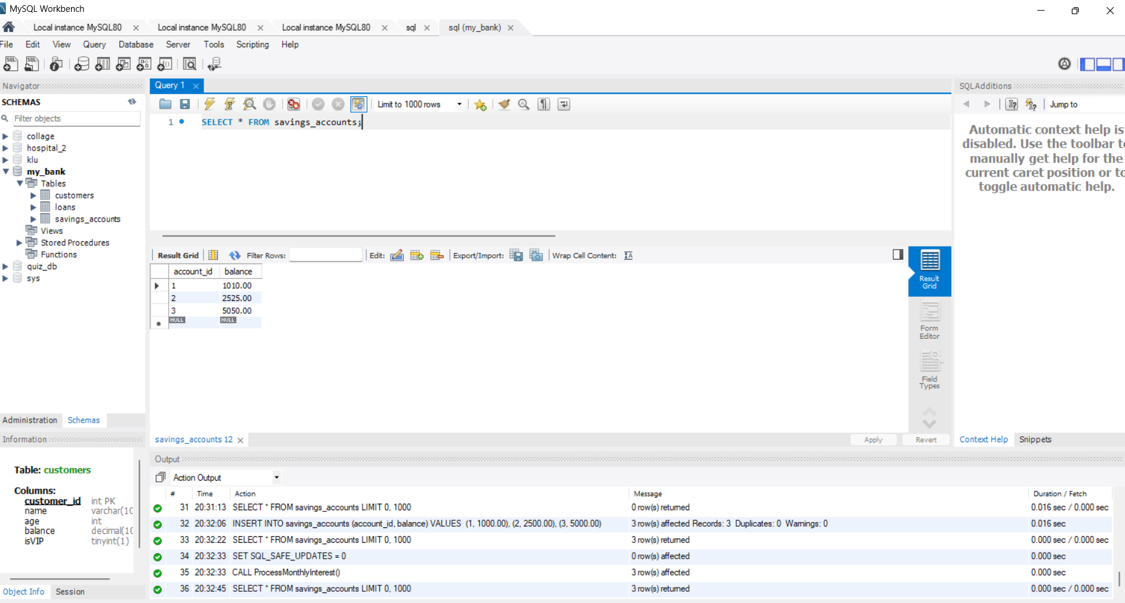

**Scenario 2:**

CREATE PROCEDURE UpdateEmployeeBonus(IN dept_name VARCHAR(50), IN bonus_percent DECIMAL(5,2))

BEGIN

UPDATE employees

SET salary = salary + (salary * bonus_percent / 100)

WHERE department = dept_name;

END $$

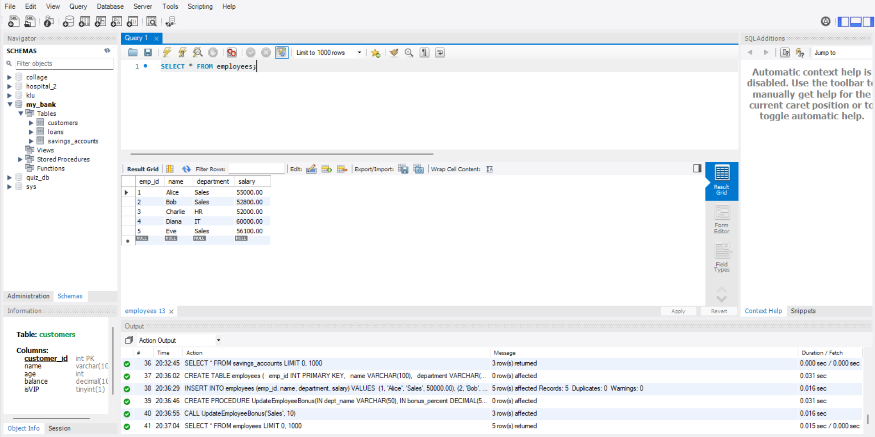

**Scenario 3:**

CREATE PROCEDURE TransferFunds(

IN from_acc INT,

IN to_acc INT,

IN amount DECIMAL(10,2)

)

BEGIN

DECLARE from_balance DECIMAL(10,2);

SELECT balance INTO from_balance FROM accounts WHERE account_id = from_acc;

IF from_balance >= amount THEN

UPDATE accounts SET balance = balance - amount WHERE account_id = from_acc;

UPDATE accounts SET balance = balance + amount WHERE account_id = to_acc;

ELSE

SIGNAL SQLSTATE '45000' SET MESSAGE_TEXT = 'Insufficient funds';

END IF;

END $$

